**Assignment**

**CSA0805 – Python Programming**

|  |  |
| --- | --- |
| **Register Number** | **192324260** |
| **Name** | **A.AVINAASH** |

**Title:**

**"Mathematical Operations Using Python's Math Module**

**Problem Statement:**

**Create a Python program that imports and utilizes the math module to perform various mathematical operations such as square root, trigonometric functions, and exponentiation.**

**Code:**

**import math**

**num1 = 25**

**num2 = 3**

**angle_degrees = 45**

**sqrt_result = math.sqrt(num1)**

**print(f"Square root of {num1} is: {sqrt_result}")**

**exp_result = math.pow(num1, num2)**

**print(f"{num1} raised to the power of {num2} is: {exp_result}")**

**angle_radians = math.radians(angle_degrees)**

**sin_result = math.sin(angle_radians)**

**cos_result = math.cos(angle_radians)**

**tan_result = math.tan(angle_radians)**

**print(f"Sine of {angle_degrees} degrees is: {sin_result}")**

**print(f"Cosine of {angle_degrees} degrees is: {cos_result}")**

**print(f"Tangent of {angle_degrees} degrees is: {tan_result}")**

**Output Screen Shots:**

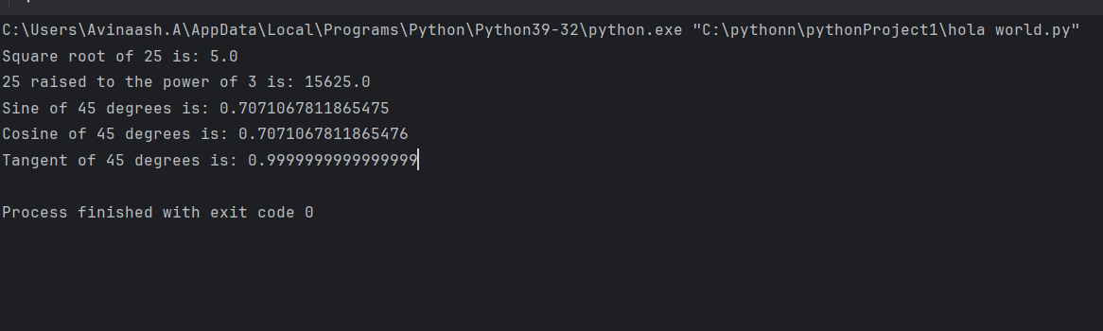

**Conclusion:**

**This Python program effectively demonstrates the use of the math module to perform various fundamental mathematical operations such as calculating square roots, performing exponentiation, and working with trigonometric functions. By leveraging these built-in functions, the program showcases how Python can handle complex mathematical computations with ease and precision. This approach is particularly useful for scientific calculations, engineering tasks, and other domains that require accurate and efficient mathematical processing.**